1. Create a directory "exercise" inside your home directory and create nested(dir1/dir2/dir3) directory structure inside "excerise" with single command.

https://kbroman.org/github_tutorial/pages/init.html

**mkdir -p exercise/{dir1,dir2,dir3}**

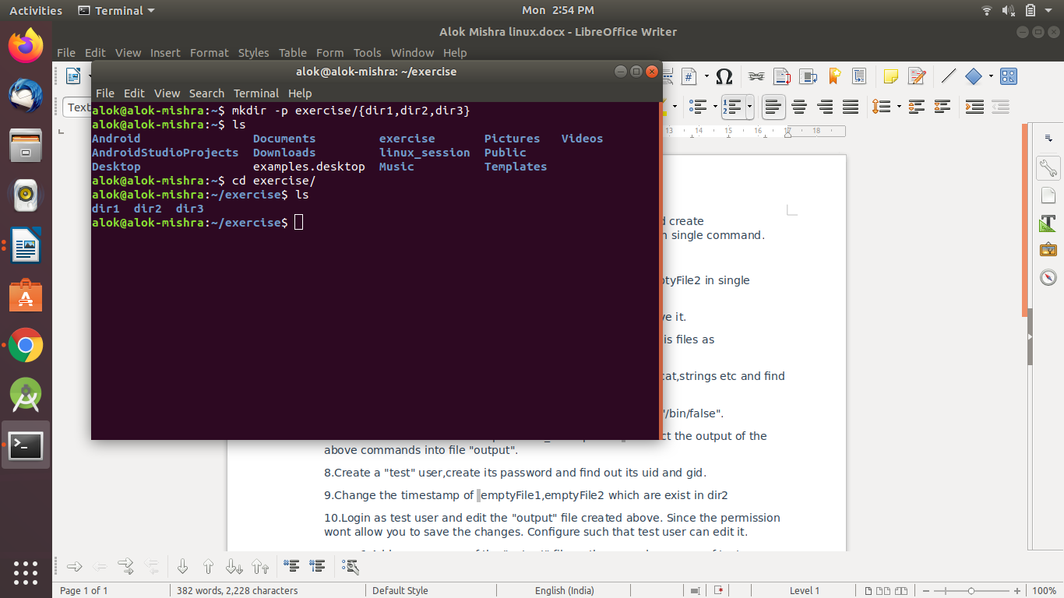

1. Create two empty files inside dir2 directory: emptyFile1,emptyFile2 in single command

**touch dir2{emptyFile1,emptyFile2}**

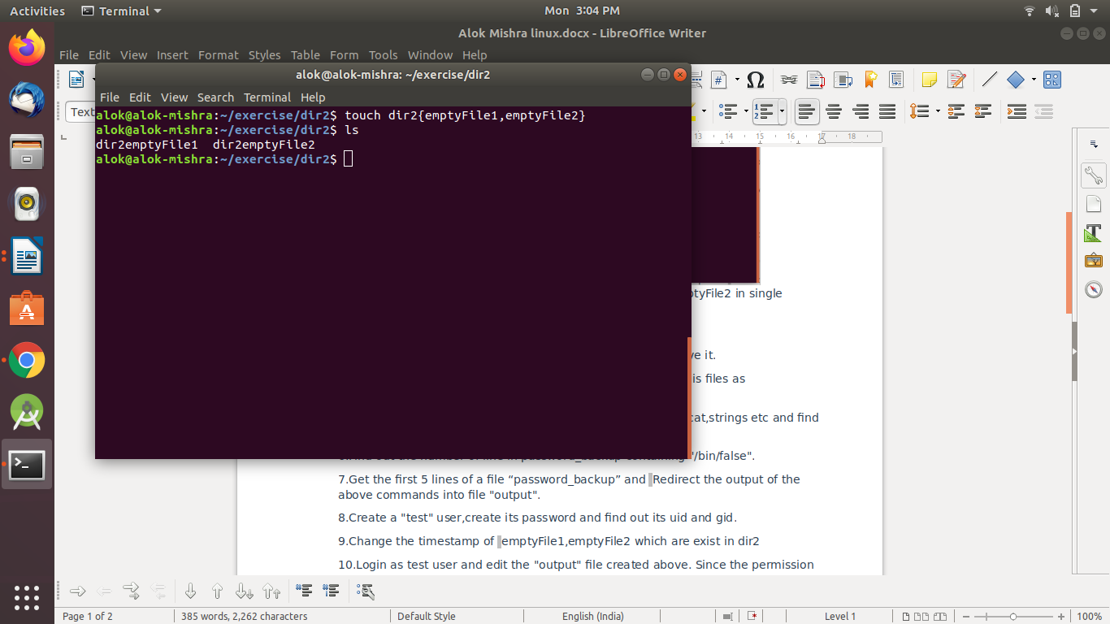

1. Create one file file1.txt containing text "hello world" and save it.

**echo "hello world" >file1.txt**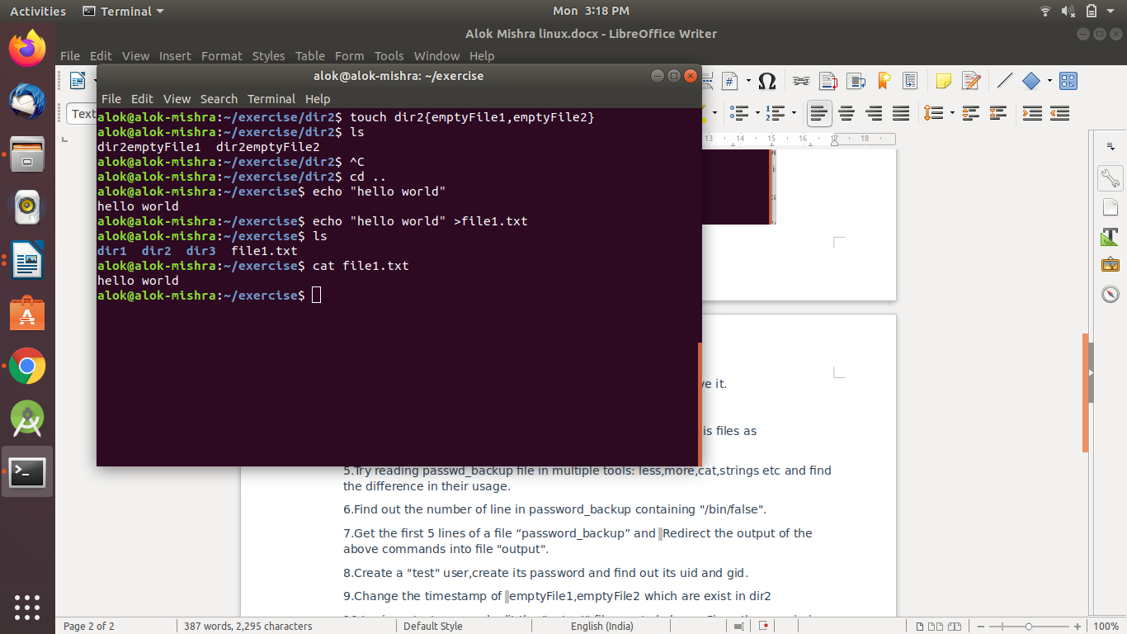

1. Find a "passwd" file using find command inside /etc. copy this files as passwd_copy and then rename this file as passwd_backup.

**sudo find /etc -name passwd**

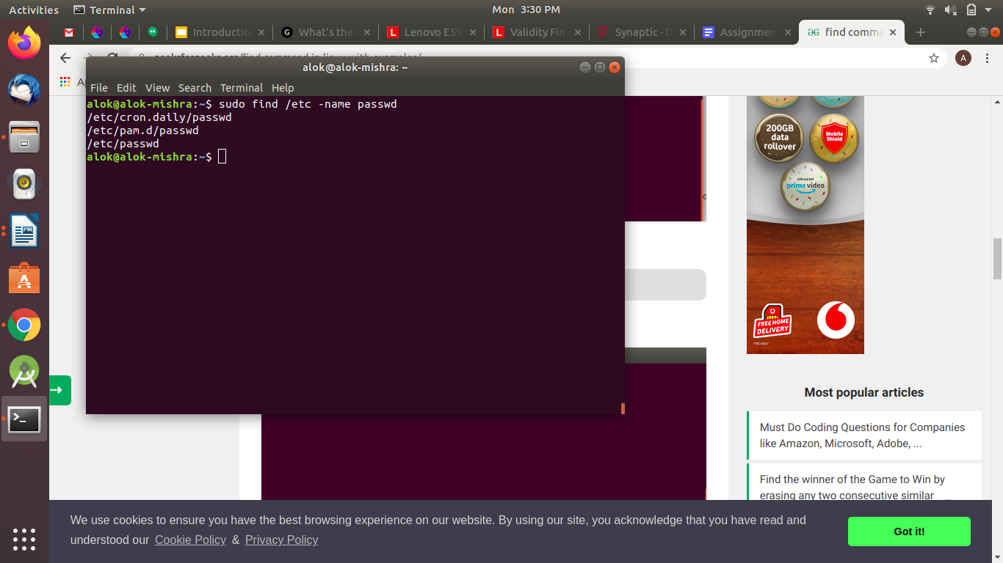

**cp /etc/passwd /home/alok/exercise/passwd_copy**

**mv passwd_copy passwd_backup**

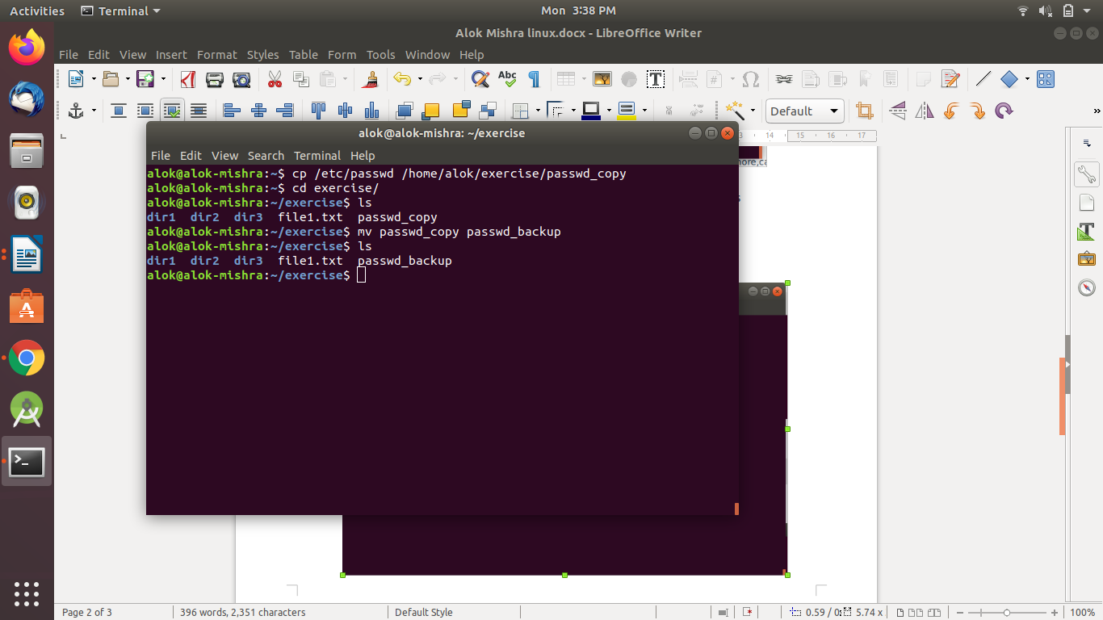

1. Try reading passwd_backup file in multiple tools: less,more,cat,strings etc and find the difference in their usage

**cat passwd_backup**

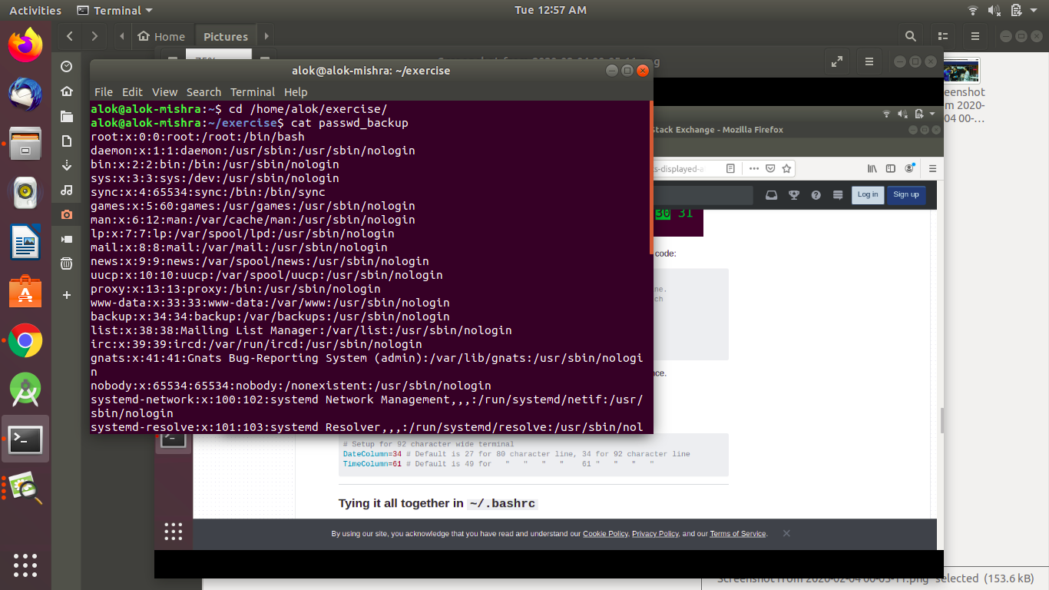

**less passwd_backup**

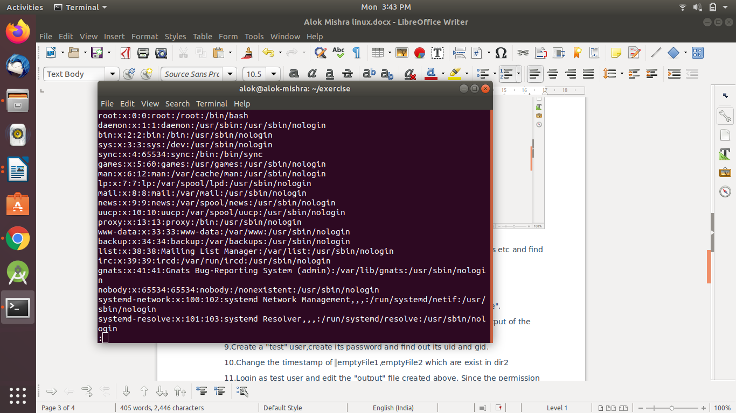

**more passwd_backup**

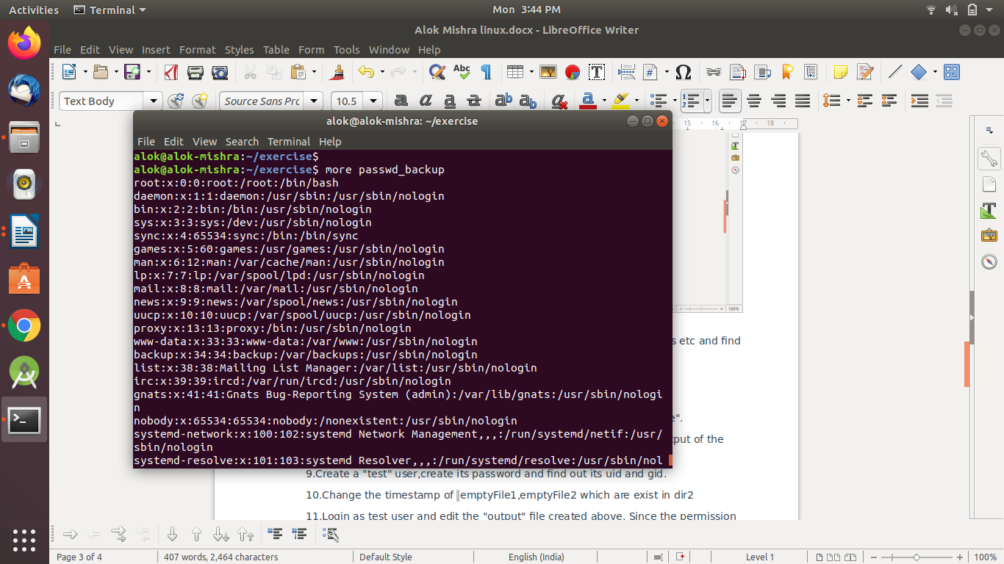

**strings passwd_backup**

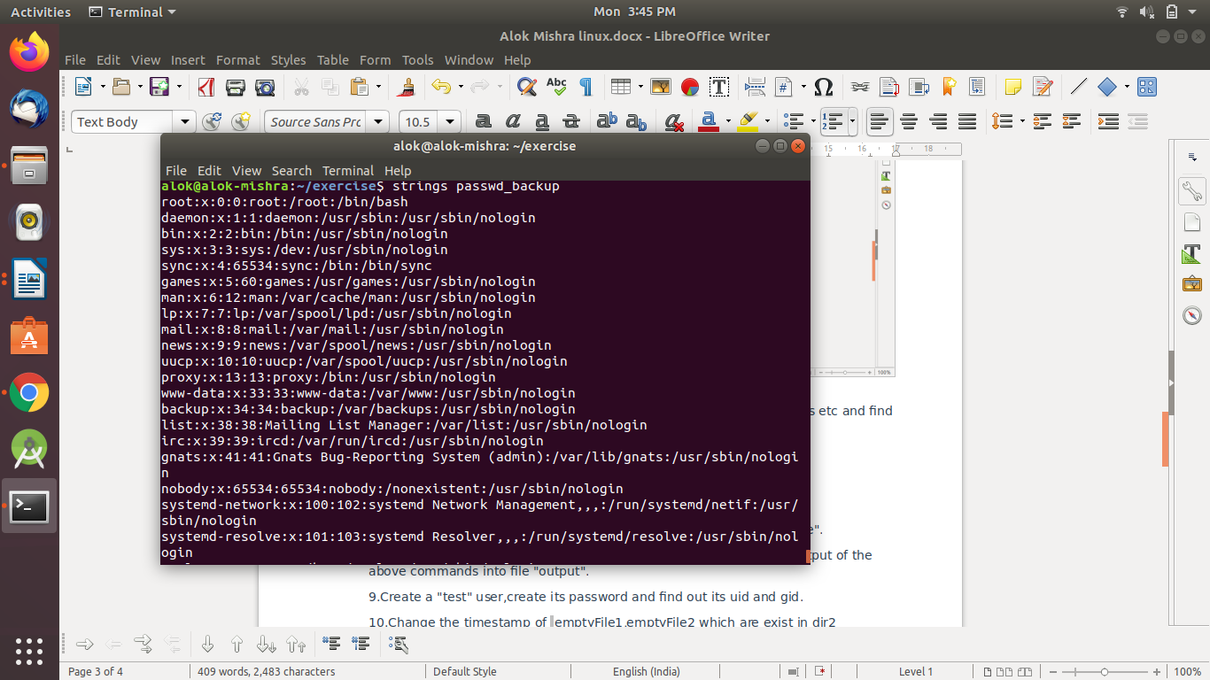

NOTE - Less is a **file reading program**, and Cat is a **string manipulation program**.

1. Find out the number of line in password_backup containing "/bin/false".

**grep -c "/bin/false" passwd_backup**

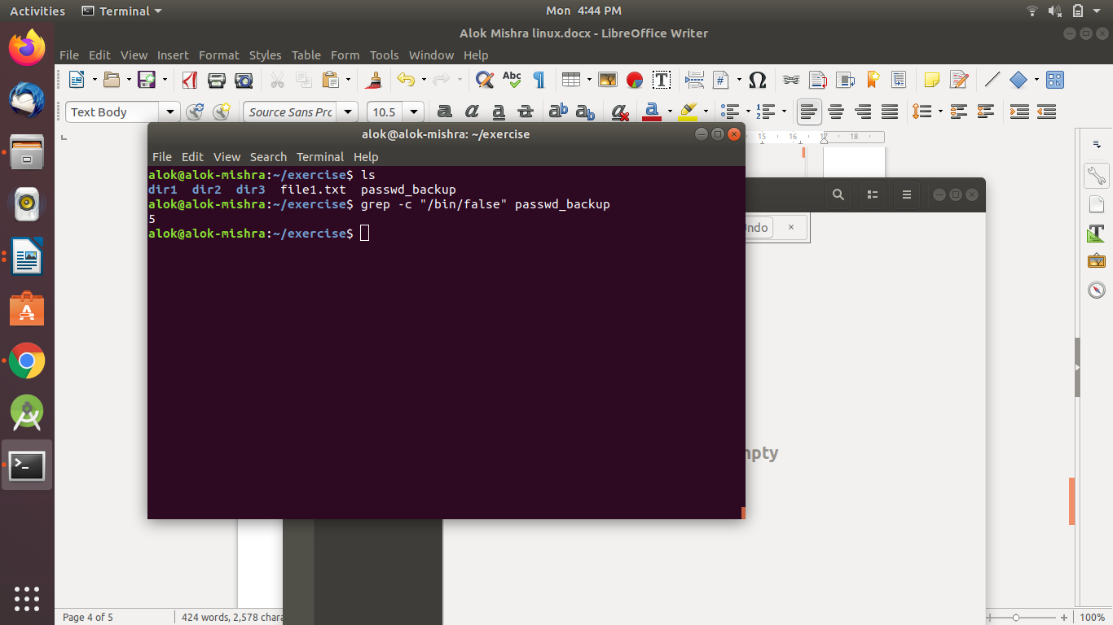

1. Get the first 5 lines of a file “password_backup” and  Redirect the output of the above commands into file "output".

**head -5 passwd_backup >output.txt**

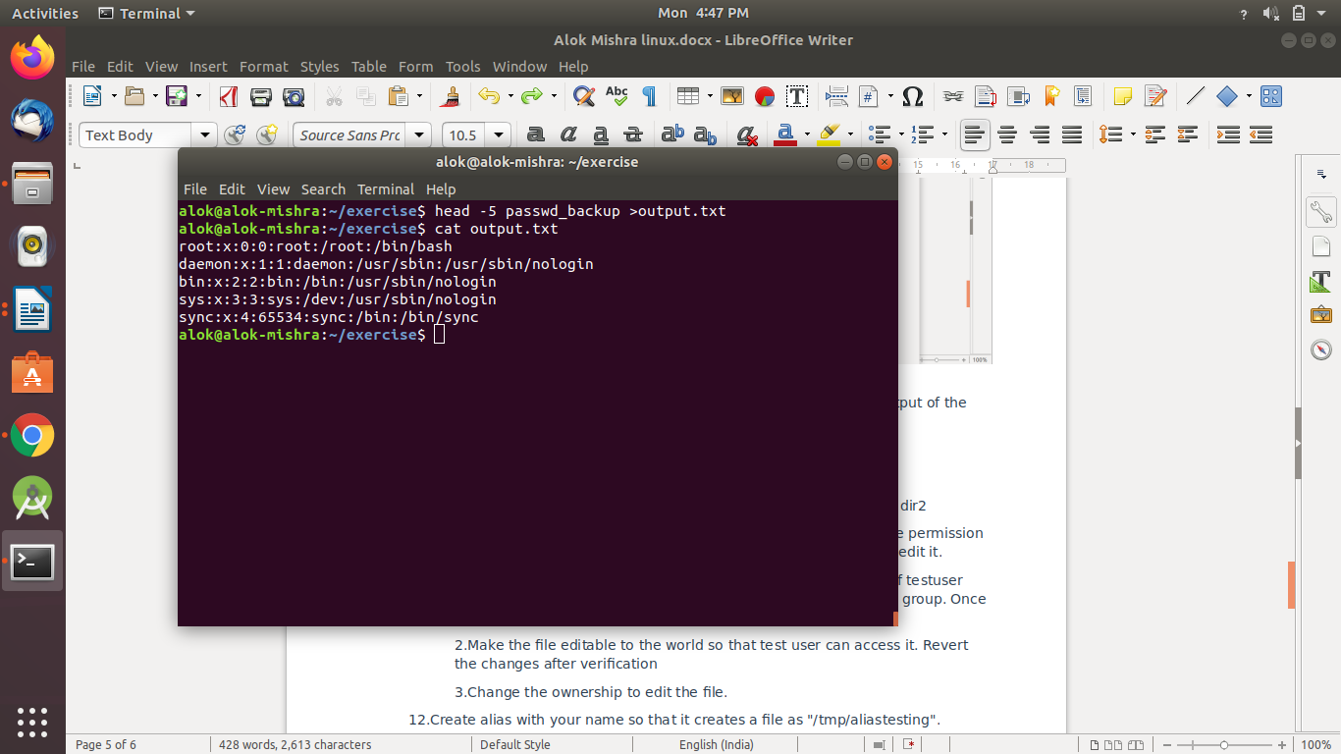

1. Create a "test" user,create its password and find out its uid and gid.

**sudo adduser test**

**#password of the file is 1234**

**id test**

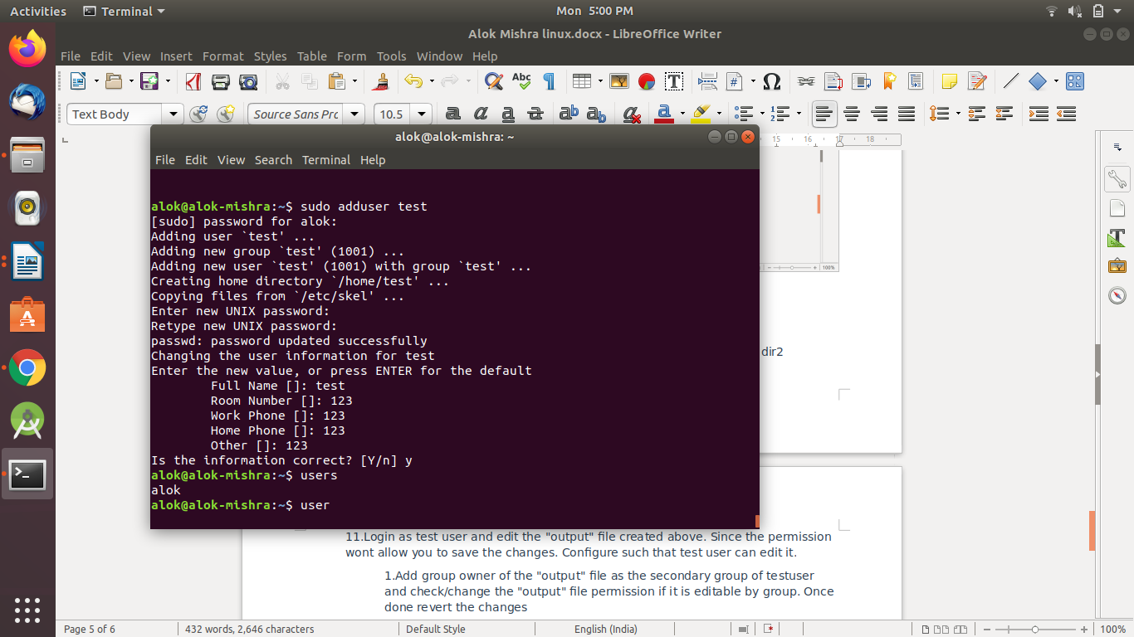

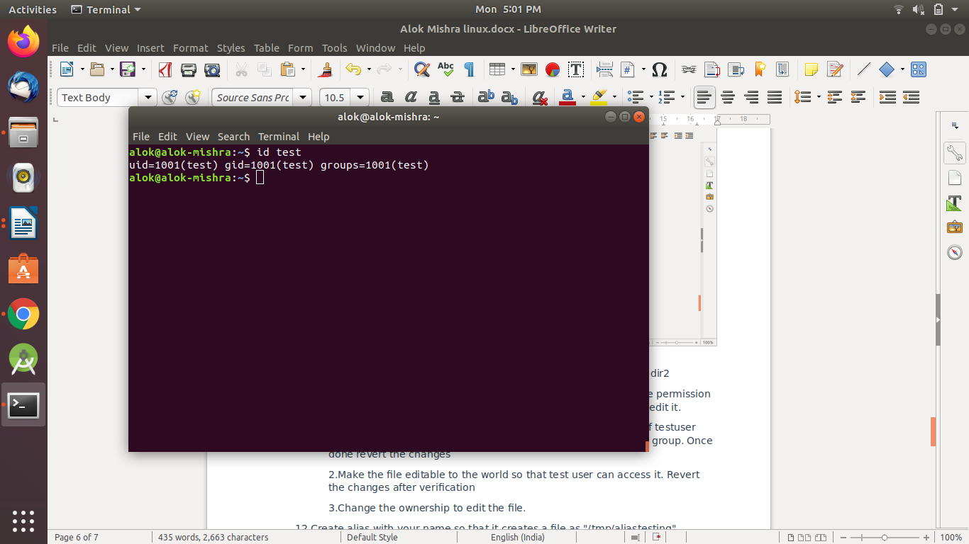

1. Change the timestamp of  emptyFile1,emptyFile2 which are exist in dir2

**touch -d '1 June 2016 11:02' dir2emptyFile1 dir2emptyFile2**

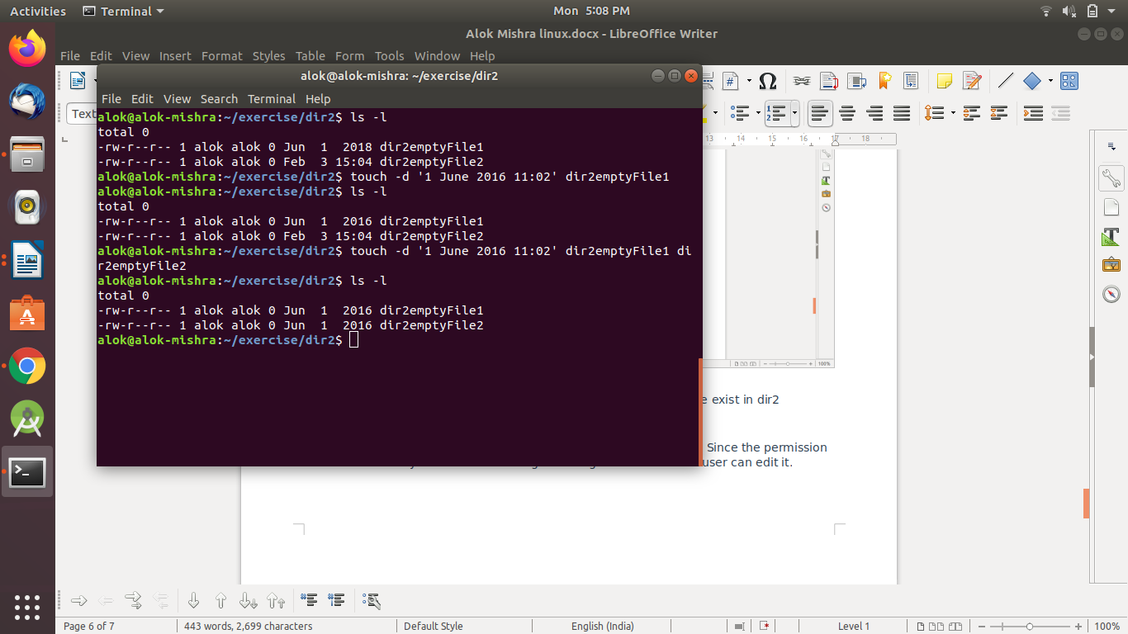

1. Login as test user and edit the "output" file created above. Since the permission wont allow you to save the changes. Configure such that test user can edit it.

**sudo chmod 770 output.txt**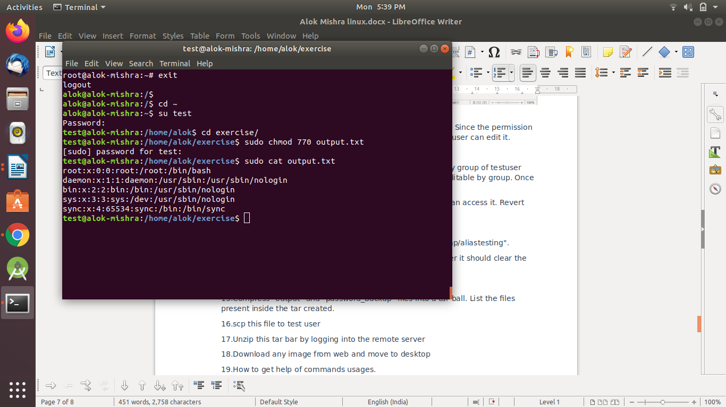

* 1. Add group owner of the "output" file as the secondary group of testuser and check/change the "output" file permission if it is editable by group. Once done revert the changes

**sudo usermod -G alok -a test**

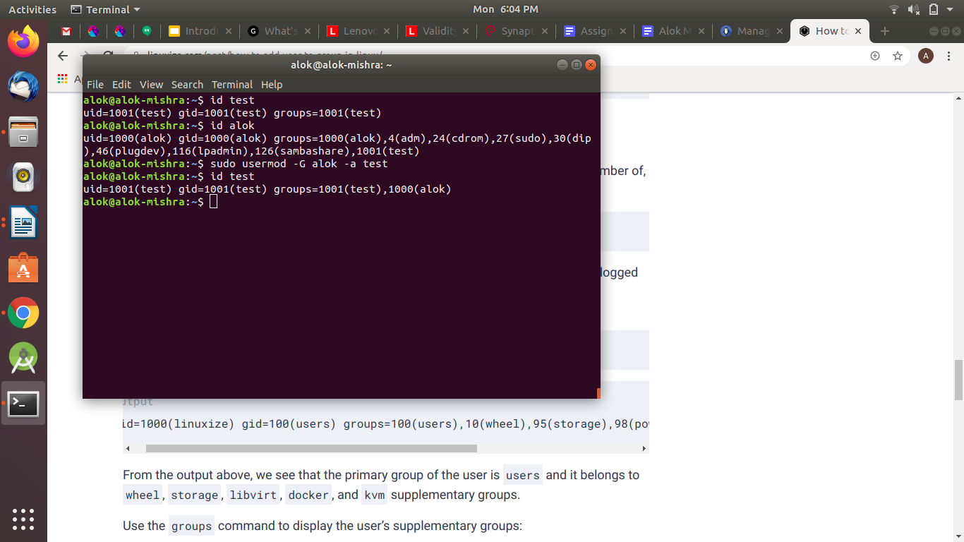

* 1. Make the file editable to the world so that test user can access it. Revert the changes after verification

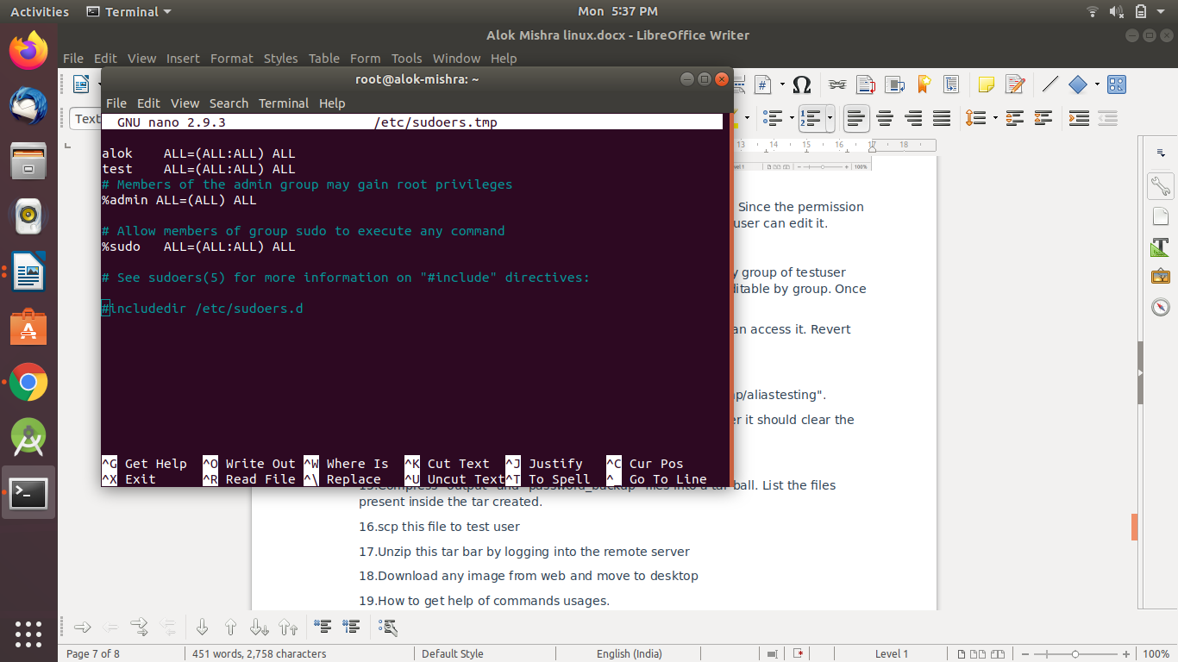

* 1. Change the ownership to edit the file.

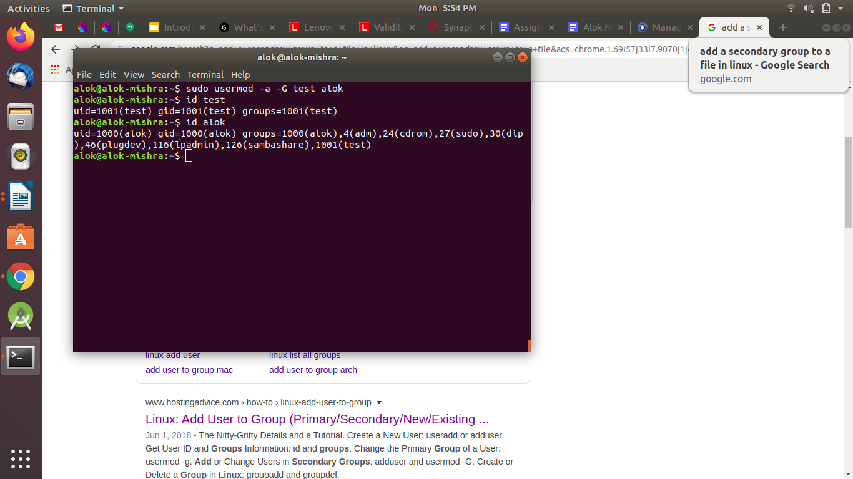

1. Create alias with your name so that it creates a file as "/tmp/aliastesting".

**alias alok=’mkdir /tmp/aliastesting’**

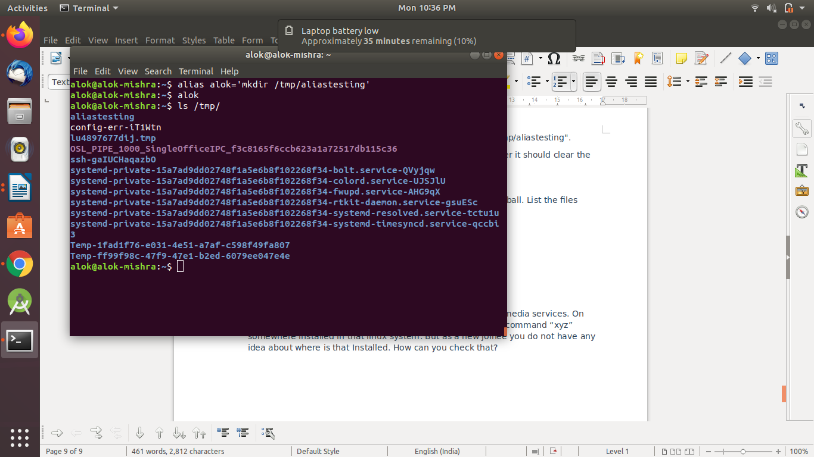

1. Edit ~/.bashrc file such that when you change to "test" user it should clear the screen and print "Welcome".

**cd /home/test/**

**vi .bashrc**

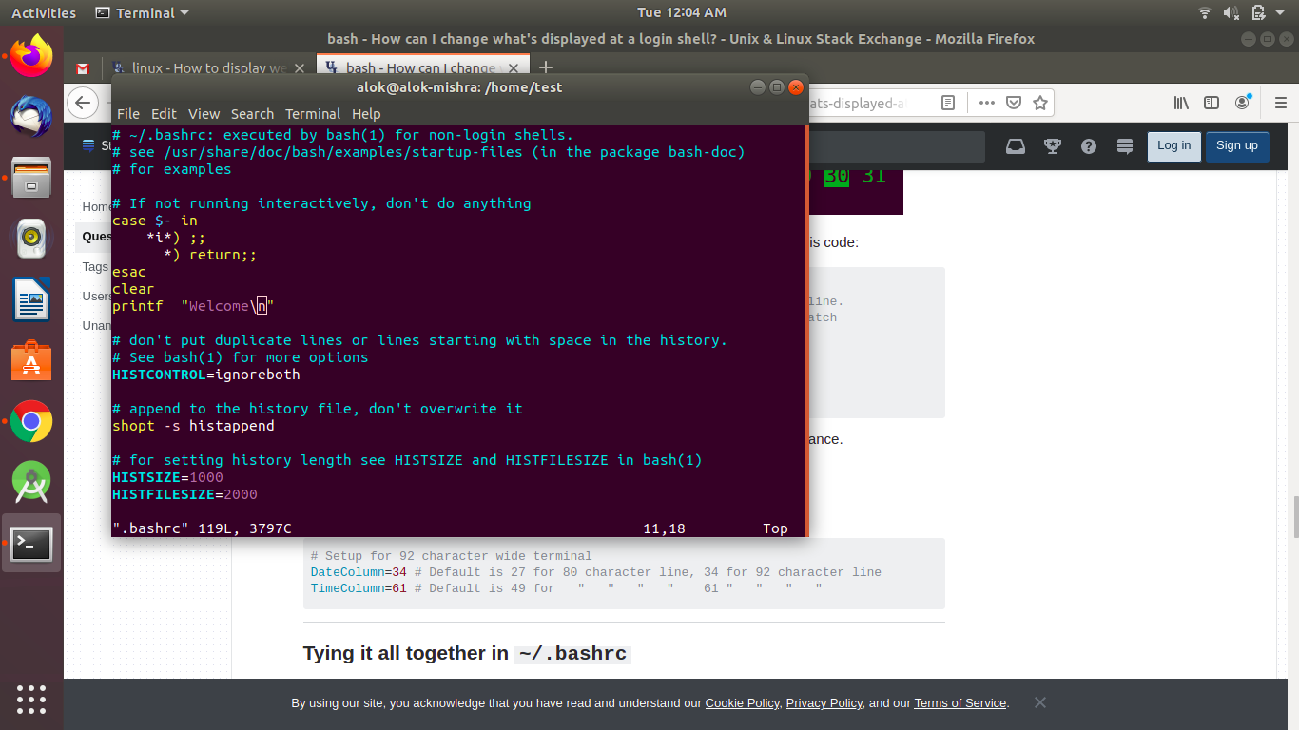

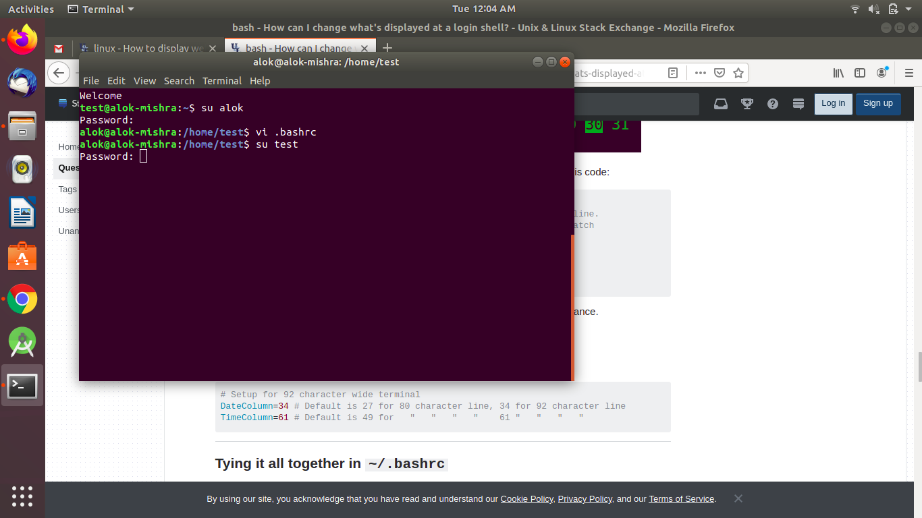

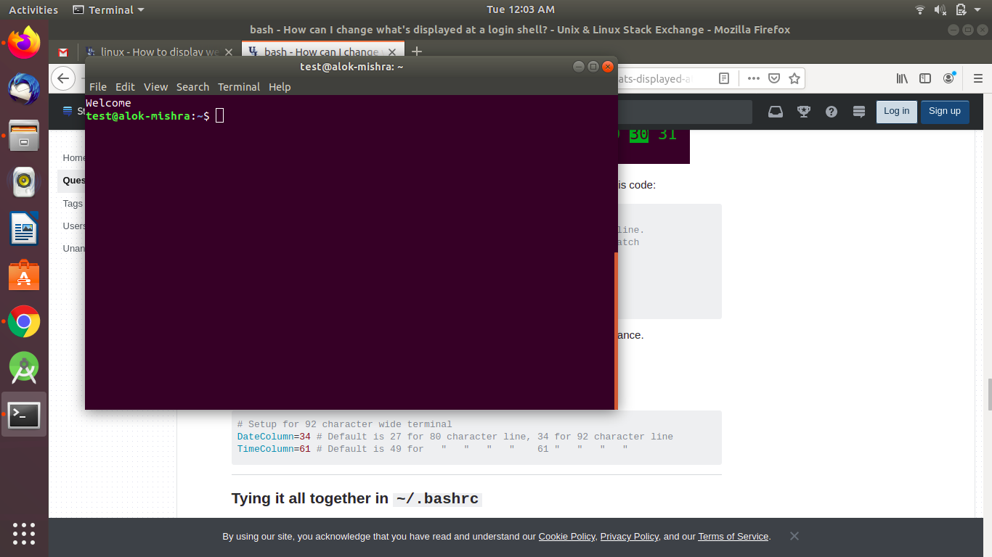

1. Install “zip” package.

**sudo apt-get install zip**

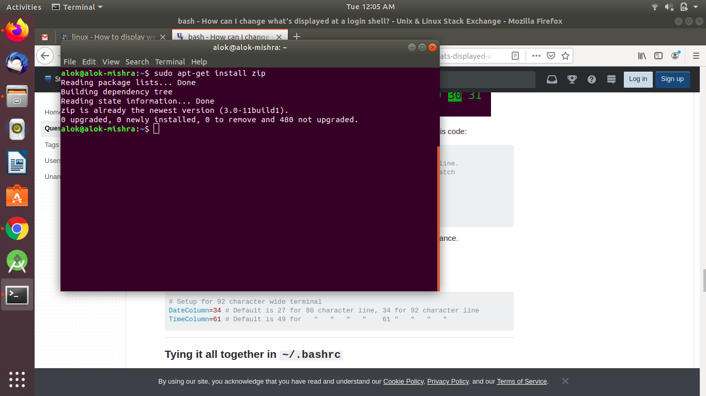

1. Compress "output" and "password_backup" files into a tar ball. List the files present inside the tar created.

**tar --list --verbose --file=compressed.tar**

**tar -cvf compressed.tar passwd_backup output.txt**

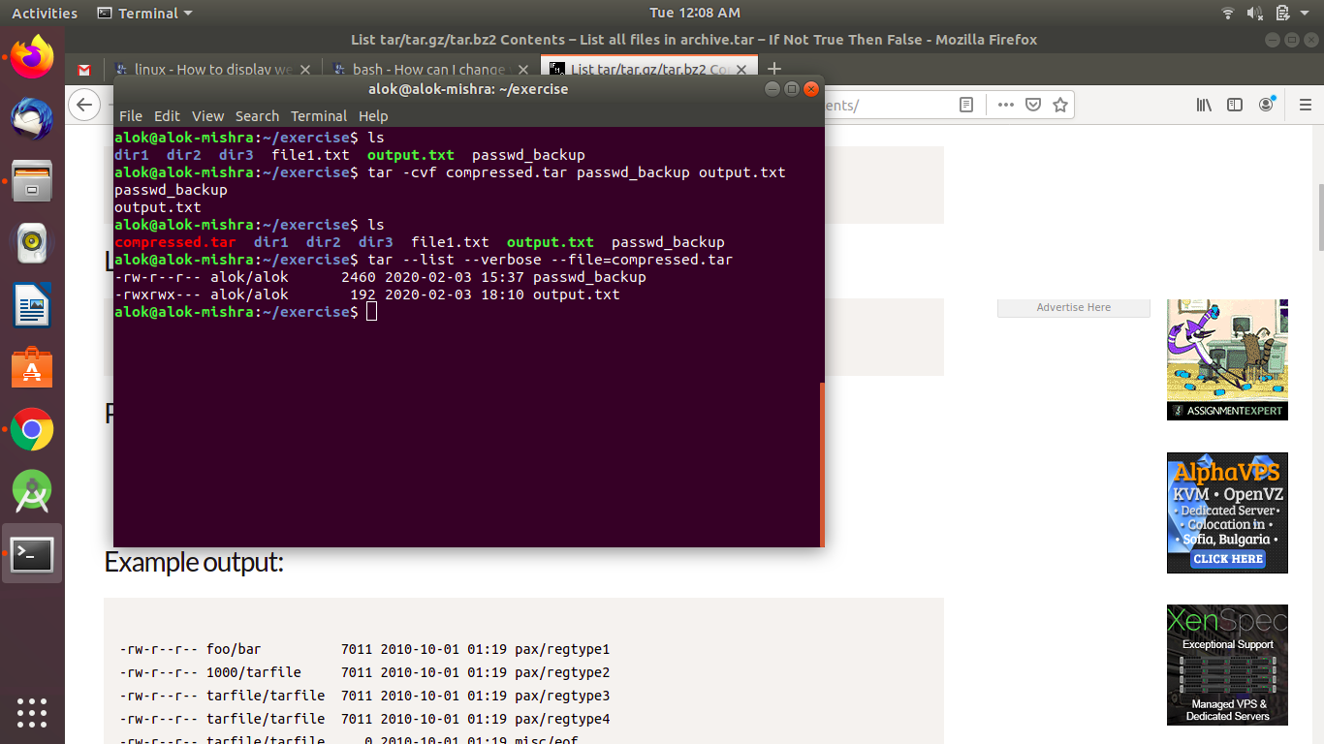

1. scp this file to test user

**scp /home/alok/exercise/compressed.tar test@alok-mishra:/home/test/new**

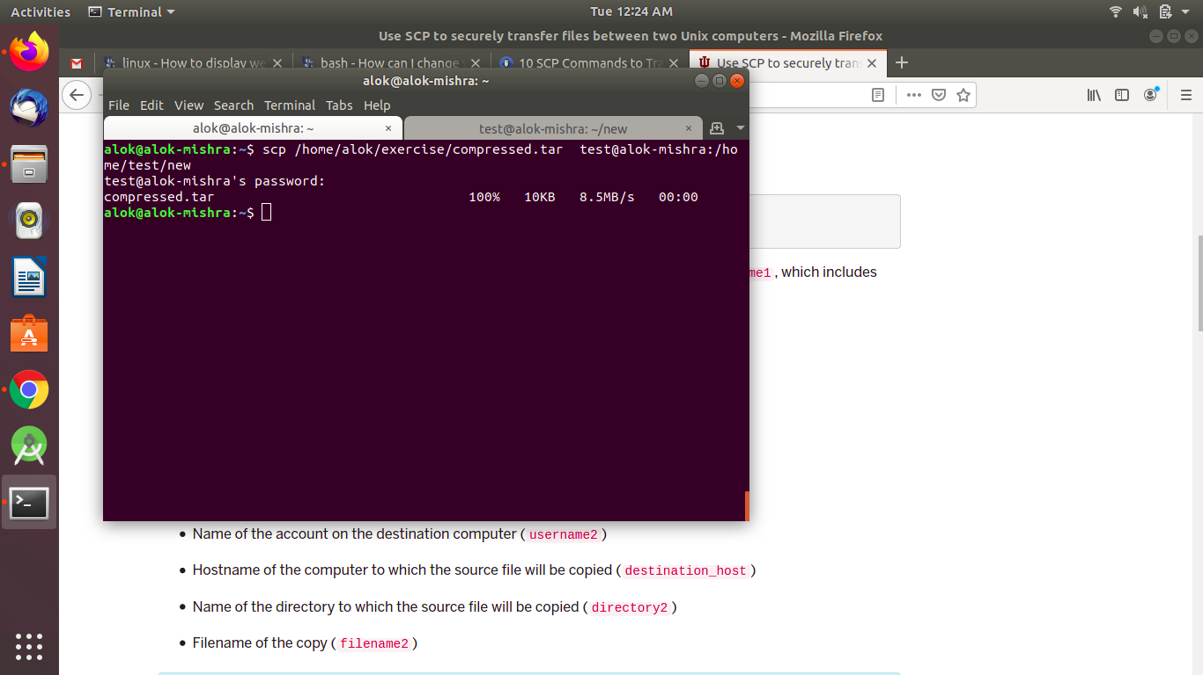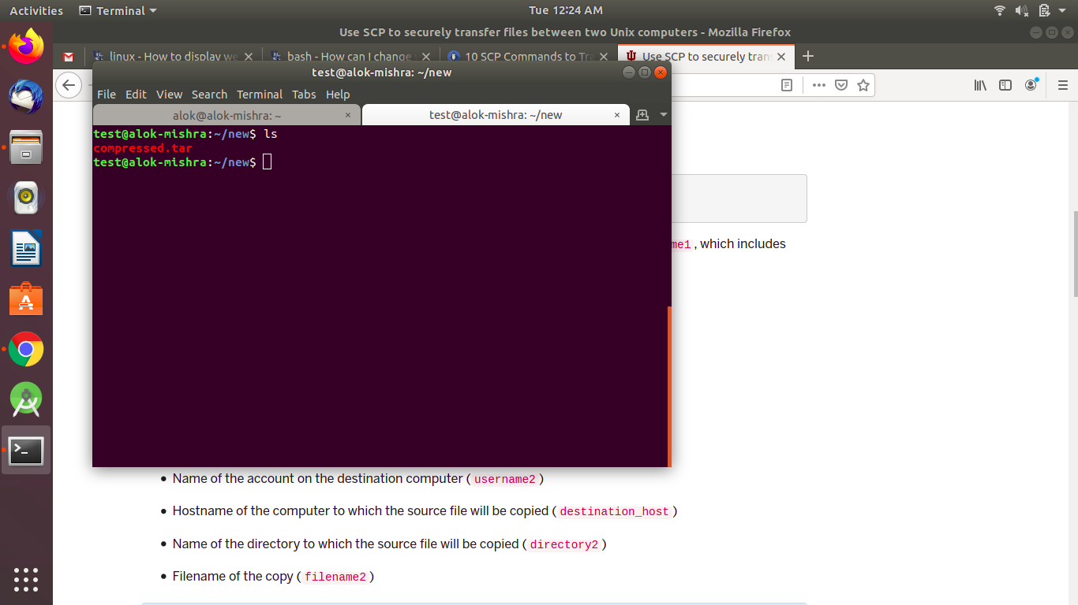

1. Unzip this tar bar by logging into the remote server

**ssh vishodu@10.1.210.113**

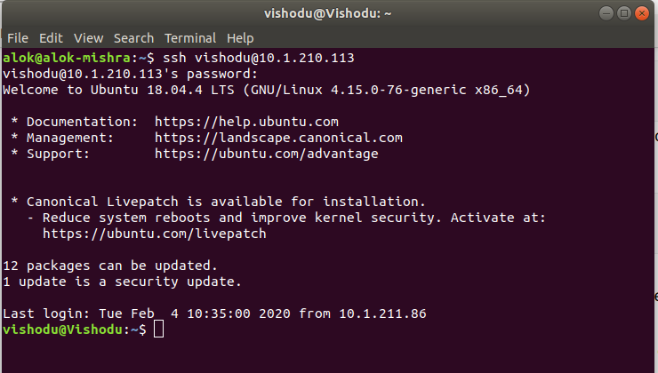

**tar -xvf testfile.tar.gz** to unzip file

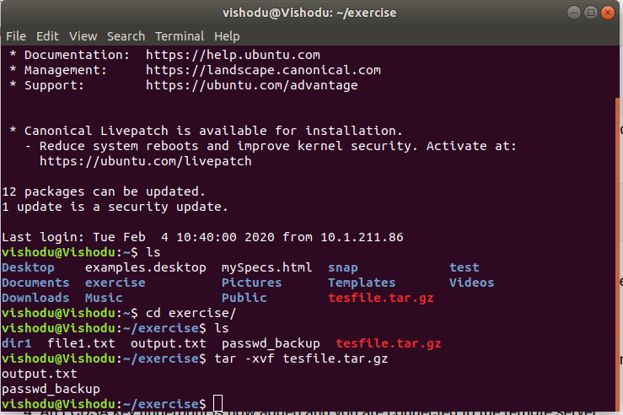

1. Download any image from web and move to desktop

**wget https://www.bennett.edu.in/wp-content/uploads/2017/07/banner-h1.jpg**

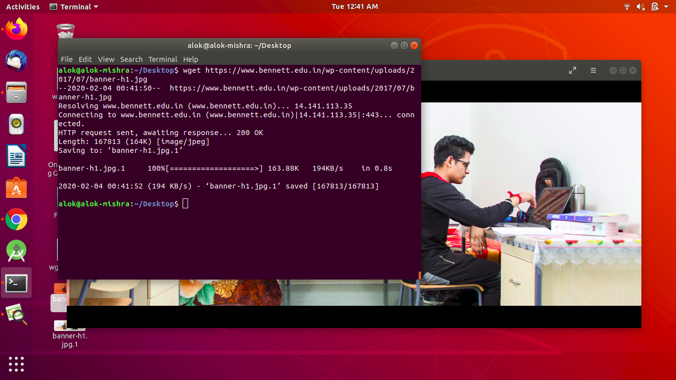

1. How to get help of commands usages.

**ls --help**

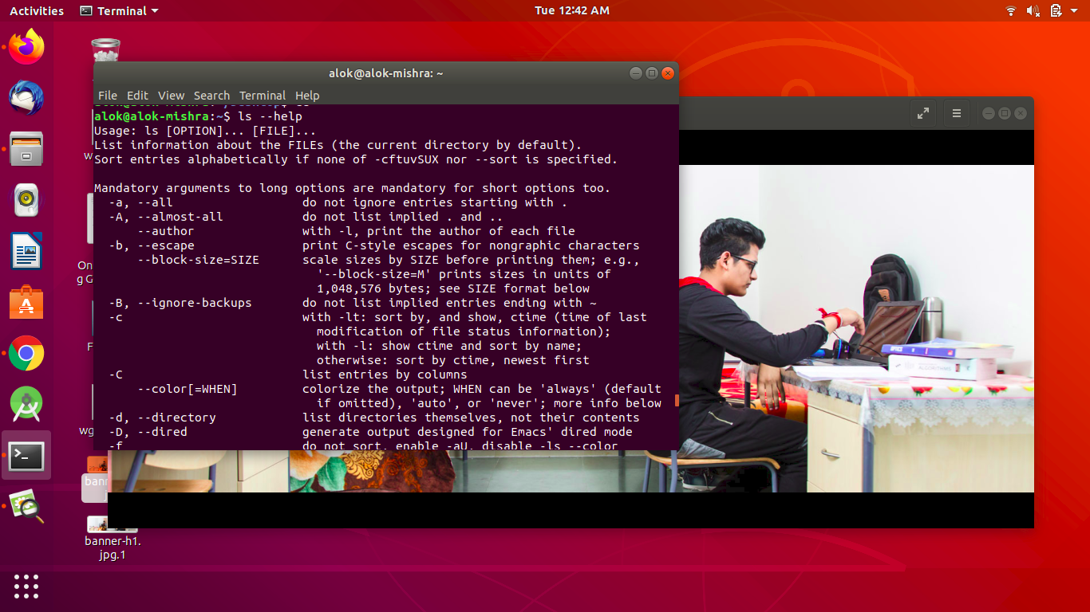

1. Create a symlink of /etc/services into /tmp/ports-info

**ln -s /etc/services /tmp/ports-info**

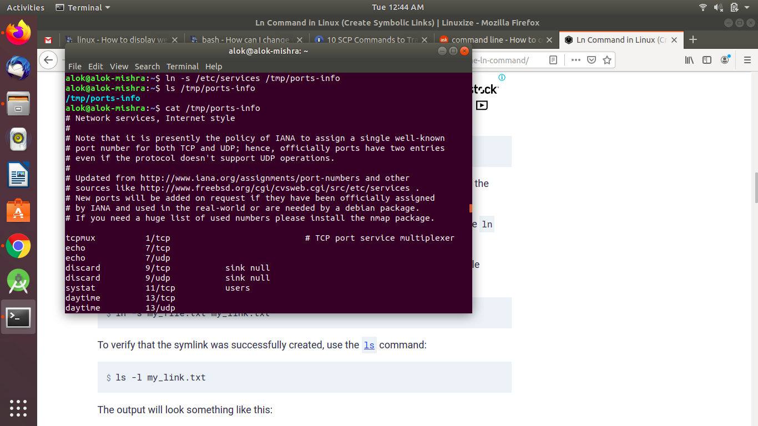

1. You are appointed as a Software/DevOps Engineer in ABC media services. On your first day you need to troubleshoot a problem. There is a command “xyz” somewhere installed in that linux system. But as a new joinee you do not have any idea about where is that Installed. How can you check that?

**dpkg -s wget**

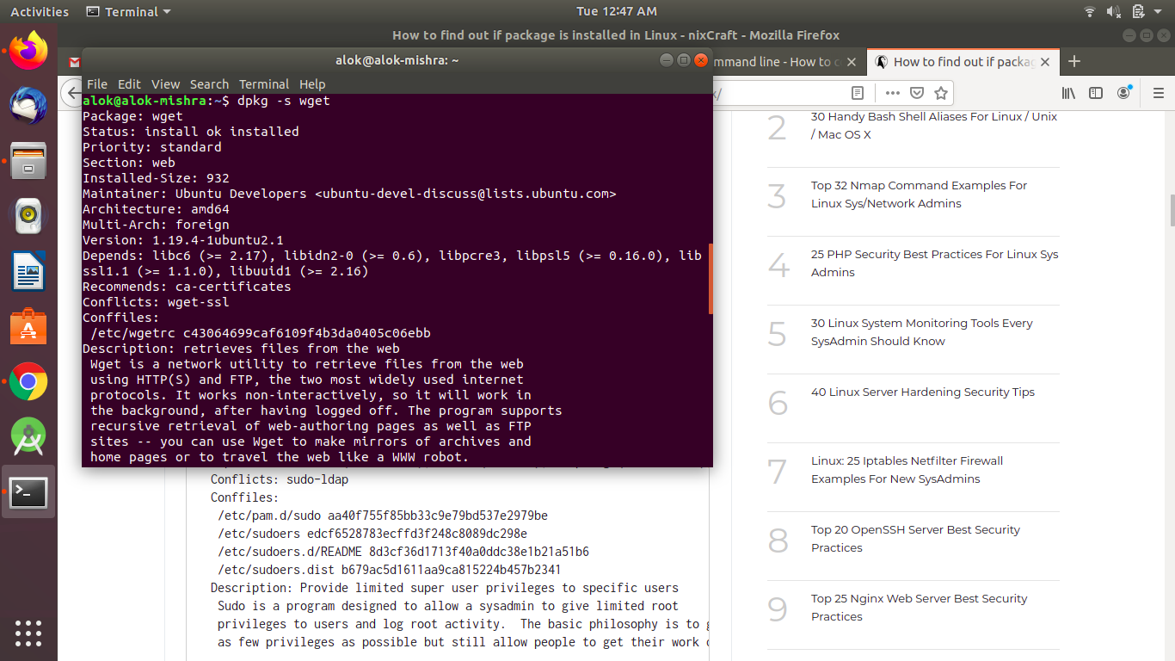

**dpkg -s sudo**

